ECA13 – MICROWAVE ENGINEERING
Assignment 2 – CO2 Case Study Report
Design and Performance Evaluation of a 10 GHz Microwave Point-to-Point Backhaul Link
Student | Dharshan.V
Register number | 192512101
Course outcome | CO2 – performance of microwave networks, active devices and passive components
Assessment | Open-ended industry case study, 100 marks (K5 Evaluate; K6 Create/Design)

Report section (required sequence) | Assessment stage | Marks
1. The Case | System data, assumptions | —
2. Component Evaluation | Stage 1 – coupler, attenuator, Wilkinson divider | 15
3. Device Principles and Source Selection | Stage 3 – Gunn, IMPATT, tubes, LO selection | 20
4. Design | Stage 2 – cavity resonator (15); Stage 4 – receiver, noise (20) | 35
5. Diagnosis | Stage 5 – field data and root-cause ranking | 20
6. Engineering Recommendation | Final decision and upgrade plan | 10
Total |  | 100

1. THE CASE
A telecom operator is upgrading a 10 GHz point-to-point microwave backhaul link. The link shows reduced received signal level, intermittent throughput loss on hot afternoons and an unexplained rise in reflected power at the transmitter output. As the appointed microwave engineer, this report evaluates the passive components, designs a thermally stable resonator, selects the active devices, analyses receiver protection and noise, diagnoses the field data, and recommends a prioritised upgrade.
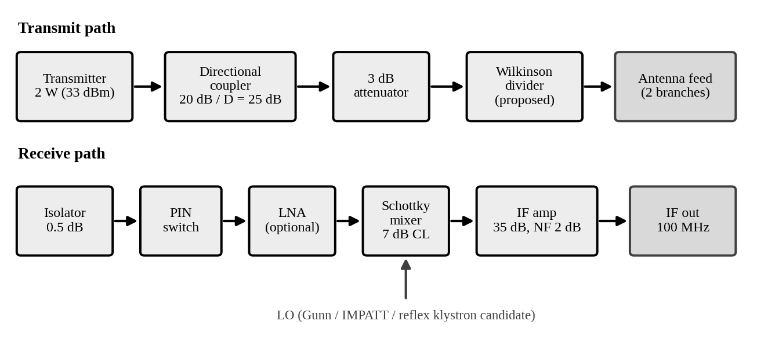
Figure 1. Proposed RF chain (transmit and receive) as given in the case

1.1 Common assumptions and constants
- Reference impedance Z₀ = 50 Ω; RF frequency 10.0 GHz; speed of light c = 2.998 × 10⁸ m/s; Boltzmann constant k = 1.381 × 10⁻²³ J/K; room temperature T₀ = 290 K.
- Powers are converted with P(dBm) = 10 log₁₀[P(mW)/1 mW]. The 2 W transmitter output is 33.01 dBm.
- The coupler insertion loss of 0.4 dB is taken as the total input-to-through-port loss. The coupled-port power is referenced to the coupler input.
- Where a value is not supplied (PIN-switch loss, circulator Tx–Rx isolation, LNA survival level, temperature rise during hot operation), the report states it as a missing parameter or as a labelled assumption rather than inventing a data-sheet value.
- Typical device ranges in Section 3 are textbook-level values [1]–[4]; they should be confirmed
- against manufacturer data sheets before procurement.

2. COMPONENT EVALUATION (Stage 1 – Passive Components, 15 marks)

2.1 Directional coupler

(i) Coupled and through-port power
P_in = 2 W = 2000 mW → 10 log₁₀(2000) = 33.01 dBm
P_c = P_in · 10^(−C/10) = 2 W × 10^(−20/10) = 2 W × 0.01 = 20 mW (13.01 dBm)
P_t = P_in · 10^(−IL/10) = 2 W × 10^(−0.4/10) = 2 × 0.9120 = 1.824 W (32.61 dBm)
The 20 dB coupling alone removes only 0.044 dB from the through line (10 log₁₀ 0.99), so most of the 0.4 dB insertion loss (≈ 0.36 dB, about 8 % of the power) is dissipative. This is a 0.18 W heat load and a first source of power loss before the antenna.

(ii) Reflection coefficient and reflected power at commissioning
|Γ| = (S − 1)/(S + 1) = (1.25 − 1)/(1.25 + 1) = 0.25/2.25 = 0.1111
Return loss RL = −20 log₁₀|Γ| = 19.08 dB; reflected-power fraction |Γ|² = 0.01235 (1.23 %)
Antenna-feed plane (through-port power 1.824 W, then 3 dB pad): P_inc = 1.824 × 0.5012 = 0.914 W
P_refl(antenna plane) = 0.914 W × 0.01235 = 11.3 mW (10.5 dBm)
Seen at the coupler plane (pad crossed again, −3 dB): P_refl = 11.3 mW × 0.5012 = 5.65 mW (7.5 dBm)
Equivalent |Γ| at the coupler plane = 0.1111 × 10^(−6/20) = 0.0557; RL = 19.08 + 6.02 = 25.1 dB
Interpretation. At VSWR 1.25 only 1.2 % of the incident power is reflected, so the antenna was well matched at commissioning. In the stated chain, however, the pad lies between the coupler and the antenna. It hides the mismatch from the coupler by 6 dB (two-way), and this matters for the directivity analysis below. If the pad were absent, the reflected power at the coupler would be 1.824 W × 0.01235 = 22.5 mW.

(iii) Directivity leakage and measurement reliability
Leakage into reverse-coupled port = P_c · 10^(−D/10) = 20 mW × 10^(−25/10) = 0.0632 mW (−11.99 dBm)
Expected reverse-coupled signal (pad in line) = 5.65 mW × 0.01 = 0.0565 mW (−12.48 dBm)
Expected reverse-coupled signal (no pad) = 22.5 mW × 0.01 = 0.225 mW (−6.48 dBm)
Leakage / signal (pad in line) = 0.0632/0.0565 = 1.12 (leakage is 12 % LARGER than the wanted signal)
Leakage / signal (no pad) = 0.0632/0.225 = 0.28 (−11.0 dB); amplitude ratio D/|Γ| = 0.0562/0.1111 = 0.506
The reverse port actually reads the vector sum of the true reflection and the leakage wave. With no pad, the measured |Γ| can lie anywhere between 0.1111 × (1 − 0.506) = 0.055 and 0.1111 × (1 + 0.506) = 0.167, i.e. VSWR 1.12 to 1.40, and the reverse reading can be wrong by −6.1 dB to +3.6 dB. With the pad in line, the leakage is about equal to the signal and the reading is essentially unusable for a VSWR 1.25 antenna.
Design Decision 1
The existing coupler is inadequate for monitoring the antenna match at this level of mismatch, because its 25 dB directivity is only 5.9 dB better than the 19.1 dB return loss being measured (and slightly worse than the 25.1 dB return loss seen through the pad). Directivity leakage (0.063 mW) is comparable to, or larger than, the wanted reverse signal (0.057 – 0.225 mW). A rule of thumb is that directivity should exceed the return loss being measured by 15–20 dB, which for VSWR 1.25 means ≥ 35–40 dB. The coupler is adequate only for detecting gross faults (VSWR above about 1.5). The practical fix is a ≥ 40 dB directivity coupler, or a calibrated reflectometer, with the pad moved ahead of the coupler.

2.2 Attenuator and matching
Input to pad (coupler through-port) P_in = 1.824 W; P_out = P_in · 10^(−3/10) = 1.824 × 0.5012 = 0.914 W (29.61 dBm)
Dissipated P_d = P_in − P_out = 1.824 − 0.914 = 0.910 W
(For the full 2 W nominal input: P_out = 1.002 W and P_d = 0.998 W ≈ 1 W.)
The pad turns about half of its input power into heat, so it needs a power rating of at least 2 W (a 2× derating margin) and a heat path.
Why a pad improves matching stability. A load reflection Γ_L seen through an A dB matched attenuator becomes Γ_in = Γ_L · 10^(−A/10) (amplitude), i.e. the return loss improves by 2A dB. A 3 dB pad improves the return loss by 6 dB. This reduces frequency pulling of the source, limits power reflected into the transmitter, and makes the source see a more constant load. The price is a 3 dB reduction of the available signal power. That is a direct 3 dB loss in EIRP or, in a receive path, a direct +3 dB on the noise figure.
Recommended placement.
- Transmit path: do not use a 3 dB pad as the main isolator in the 2 W path. It wastes half the power, so use a low-loss ferrite isolator (≈ 0.5 dB) for source protection. If a pad is retained, place it ahead of the coupler so that the coupler still sees the full antenna reflection.
- Low-power uses where a pad is appropriate: the LO line to the mixer (to set drive and improve LO-port match), the source-to-oscillator buffer, and test or monitor ports.
- Receive path: never place a pad between the antenna and the first low-noise stage, because its loss adds directly to system noise figure. It is acceptable after the LNA, where the noise penalty is divided by the LNA gain.

2.3 Wilkinson power divider
Quarter-wave section impedance: Z_q = √2 · Z₀ = 1.4142 × 50 = 70.71 Ω
Guided wavelength: λg = c /(f · √εeff) = 2.998 × 10⁸ /(10 × 10⁹ × √2.2) = 0.02998 / 1.4832 = 20.21 mm
Quarter-wave length: ℓ = λg/4 = 20.21 / 4 = 5.05 mm
Isolation resistor (equal split): R = 2 · Z₀ = 100 Ω
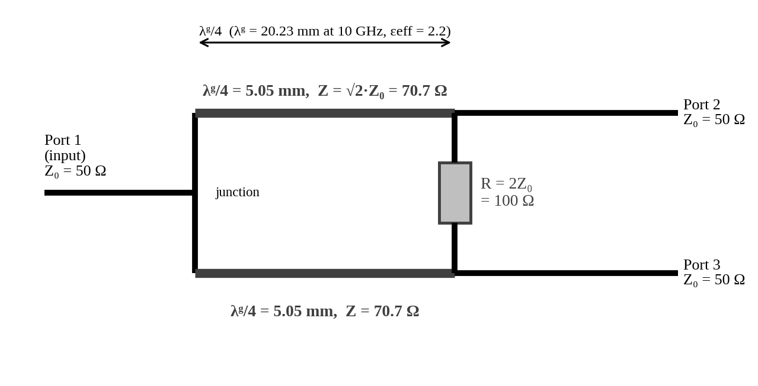
Figure 2. Wilkinson equal-split divider sketch (Z₀ = 50 Ω, 10 GHz, εeff = 2.2)
Comparison with a simple T-junction (all ports 50 Ω; Pozar [1]):
Property | Wilkinson divider | Resistorless T-junction
Matching | All three ports matched at f₀ (S₁₁ = S₂₂ = S₃₃ = 0). | Cannot match all ports. Input sees 25 Ω (VSWR 2.0): |S₁₁| = 1/3, so 11 % of the power is reflected (RL 9.5 dB).
Insertion loss | S₂₁ = S₃₁ = −3.01 dB (ideal split), plus about 0.1–0.3 dB of line and dielectric loss. | S₂₁ = S₃₁ = −3.52 dB (2/3 in voltage) and the remaining power is reflected.
Output isolation | S₂₃ = 0 at f₀ (practically 20–30 dB). Reflections from one branch do not reach the other. | S₂₃ = −3.52 dB, i.e. practically no isolation. A fault or mismatch in one branch strongly disturbs the other.
Bandwidth / size | Narrowband (approx. 10–20 % fractional); needs a 100 Ω film resistor. | Very broadband and simplest, but poor performance.

Suitability for the two-branch antenna feed. Yes. The Wilkinson divider is suitable. It presents a matched input to the transmitter, isolates the two branches from each other (so one damaged antenna feed does not detune the other), and the 5.05 mm quarter-wave line is easy to realise in microstrip at 10 GHz. Three cautions apply. (1) Each branch receives only half of the power (−3 dB), so the benefit must come from the second antenna and not from more power. (2) The 100 Ω resistor dissipates up to about P/4 (≈ 0.46 W for 1.82 W input) if one output is fully reflecting, so a rating of at least 1 W is advisable. (3) Equal branch loads are assumed. The measured port-to-port isolation should be verified on a VNA.

3. DEVICE PRINCIPLES AND SOURCE SELECTION (Stage 3 – 20 marks)

3.1 Device principles

Gunn diode – transferred-electron effect
In n-type GaAs (or InP) the conduction band has a central valley with low effective mass and high mobility, and satellite valleys about 0.3 eV higher with high effective mass and low mobility [2][5]. Above a threshold field (about 3 kV/cm in GaAs) electrons are transferred to the satellite valley, so their average drift velocity falls as field rises. This is negative differential mobility, and it gives a negative differential resistance at the terminals. When the doping–length product n₀L exceeds about 10¹² cm⁻², the uniform field is unstable. A high-field domain forms near the cathode, drifts to the anode at about 10⁵ m/s, and each arrival produces a current pulse. The transit-mode frequency is f ≈ v/L, so L ≈ 10⁵/10¹⁰ = 10 µm for 10 GHz. Placed in a resonator, the negative resistance cancels circuit loss and sustains oscillation at the resonator frequency.

IMPATT diode – avalanche and transit-time effects
A reverse-biased p–n diode is driven into avalanche breakdown. Impact ionisation makes the avalanche current lag the RF voltage by about 90° (injection delay). The generated carriers then drift through the drift region at saturated velocity, giving a further transit-time delay of roughly 90°. The terminal current is thus about 180° out of phase with the RF voltage, which is a negative resistance, at f ≈ v_s/(2W). For v_s ≈ 10⁵ m/s and W ≈ 5 µm this is 10 GHz [2][6].
Evaluation as a communications LO. The IMPATT delivers the highest power of the three solid-state devices (typically watts at X-band, efficiency 5–20 %). However, avalanche is a noisy process, so AM and FM noise are high (noise measure of the order of 30 dB or more) and the diode needs a stiff, low-ripple constant-current bias with good heat sinking. It is attractive as a power source (especially injection-locked) but a poor choice for a low-phase-noise LO.

Reflex klystron, TWT and magnetron
- Reflex klystron (oscillator): a beam accelerated through a single cavity gap is velocity-modulated by the cavity field, then repelled by a negative repeller electrode and returns. The returning electrons bunch and re-cross the gap in the decelerating phase when the transit time is (n + ¾) RF cycles, giving up energy to the cavity and sustaining oscillation. Power is tens to a few hundred mW, and tuning is by the cavity (mechanical) and repeller voltage (electronic, tens of MHz).
- Travelling-wave tube (amplifier): an electron beam travels along a slow-wave structure (helix) where the RF wave is slowed to about the beam velocity. Continuous synchronous interaction bunches the beam and transfers its kinetic energy to the wave, giving 20–50 dB gain over a wide bandwidth and watts to kilowatts of output.
- Magnetron (crossed-field oscillator): electrons spiral between a central cathode and a multi-cavity anode under crossed E and B fields. Rotating electron spokes synchronise with the cavity π-mode field and give up energy to it. It gives very high power (kW to MW pulsed) at high efficiency, but with a non-coherent spectrum and poor frequency stability.
Oscillator versus amplifier. An oscillator converts DC to RF with no RF input. Its frequency is set by its own resonator and positive feedback (a negative-resistance device in a resonator). An amplifier needs an input signal and increases its power while preserving its modulation, so it can be used in a coherent chain. Low-power LO generation: Gunn diode (preferred) or reflex klystron (legacy). High-power transmission: TWT (amplifier, coherent), magnetron (oscillator, radar and heating, non-coherent), IMPATT or a solid-state power amplifier for the watt level.

3.2 Quantitative comparison and selection of the 10 GHz LO
Criterion | Gunn | IMPATT | Reflex klystron
Output power at 10 GHz (typical) | ≈ 10–200 mW (up to ≈ 1 W special) | ≈ 0.5–5 W CW | ≈ 10–500 mW
Phase / FM noise | Low–moderate; much improved by a high-Q cavity or DR | High (avalanche noise); worst of the three | Lowest (very clean spectrum), but sensitive to supply ripple and microphonics
Bias / supply | Single low voltage, ≈ 7–12 V, 0.1–0.5 A | 60–100+ V constant current; needs a low-noise regulated supply | Beam ≈ 300 V, repeller −(50–300) V and heater; warm-up needed
Temperature sensitivity | Moderate; frequency and power drift with case temperature (reduced with Invar cavity and AFC) | High; thermal runaway risk, strong heat-sinking needed | Moderate; cavity expansion and supply drift
Size | Small (waveguide or microstrip) | Small, but heat sink adds bulk | Large, tube with several supplies
Maintenance / life | Long, solid state, no warm-up | Medium; ageing under high junction temperature | Limited tube life (cathode and heater), obsolete

The ranges above are typical textbook-level values [2][3][4]. The weighted decision matrix below uses the author's engineering scores (1 = poor, 5 = excellent) for this 10 GHz backhaul LO application.
Criterion (weight) | Weight | Gunn | IMPATT | Reflex klystron
Output power adequacy for 50 mW need | 15 | 4 | 5 | 4
Phase / frequency noise | 25 | 4 | 1 | 5
Bias and supply simplicity | 15 | 5 | 2 | 1
Temperature sensitivity (after stabilisation) | 15 | 3 | 2 | 3
Size and integration | 10 | 5 | 4 | 1
Maintenance and life | 20 | 5 | 3 | 1
Weighted score (out of 100) | 100 | 86 | 52 | 55

Score = Σ(weight × score)/5. Gunn: (60 + 100 + 75 + 45 + 50 + 100)/5 = 86; IMPATT: 52; klystron: 55. Gunn leads clearly and stays ahead even if the phase-noise weight is raised, because its main weakness (thermal drift) is addressed by the Invar cavity and AFC in Section 4.1.

Mixer drive calculation
Required reduction = 10 log₁₀(P_source / P_mixer) = 10 log₁₀(50 mW / 10 mW) = 10 log₁₀(5) = 6.99 dB ≈ 7.0 dB
This is the ideal minimum. In practice the LO path already has insertion loss (coupler, isolator or waveguide transitions, typically 0.5–1.5 dB), so the added attenuator would be smaller than 7 dB. Mismatch is also important: the Schottky diode impedance changes with drive level and temperature, so the delivered power differs from the matched calculation (a VSWR of 1.5 at the LO port already costs 10 log₁₀(1 − 0.2²) = 0.18 dB and also causes frequency pulling). Source power also varies with temperature and ageing. A variable attenuator or a fixed pad trimmed by measurement is therefore recommended, with the mixer drive monitored.
Design Decision 3
I recommend a cavity-stabilised Gunn oscillator (Invar cavity, varactor AFC) as the 10 GHz LO, and a solid-state (GaAs/GaN) power amplifier driven by this stable source for the 2 W transmitter, because the Gunn device gives sufficient power (≥ 50 mW), low noise once resonator-stabilised, a simple low-voltage supply, small size and long life. The IMPATT oscillator has too much noise for a communications LO, the reflex klystron is bulky with several high-voltage supplies and limited life, the TWT is unnecessary at 2 W, and the magnetron is non-coherent.

Two measurements to validate the selection:
- LO frequency versus temperature in a thermal chamber (for example 0 to 60 °C) using a frequency counter or spectrum analyser. The cavity-limited drift must be ≤ 0.3 MHz per 20 °C and AFC lock must hold.
- SSB phase noise (for example at 10 kHz and 100 kHz offsets) with a phase-noise analyser or spectrum analyser, compared with the modem's phase-noise mask. (Also verify LO power at the mixer port = 10 mW ± 1 dB.)

4. DESIGN

4.1 Cavity resonator and frequency stability (Stage 2 – 15 marks)
Role in the oscillator. A cavity resonator is a high-Q, frequency-selective circuit coupled to the negative-resistance device. The oscillation frequency settles where the device's reactance cancels the cavity's, so the resonant frequency f₀ sets the output frequency. The quality factor Q (energy stored per cycle/energy lost) controls how steeply the cavity reactance changes with frequency. A higher loaded Q therefore pulls the oscillator less when the device, bias or load changes, and also lowers close-in phase noise (Leeson [7]: noise power ∝ 1/Q_L²). The stability improvement is of the order of the ratio of the loaded Q of the cavity to the Q of the unstabilised circuit.

Cavity length for TE101 resonance at 10 GHz
f₀ = (c/2) · √[(1/a)² + (1/d)²] → 1/d² = (2f₀/c)² − 1/a²
2f₀/c = 2 × 10 × 10⁹ / 2.998 × 10⁸ = 66.71 m⁻¹ = 0.06671 mm⁻¹; (2f₀/c)² = 4.4506 × 10⁻³ mm⁻²
1/a² = 1/(22.86 mm)² = 1.9136 × 10⁻³ mm⁻²
1/d² = 4.4506 × 10⁻³ − 1.9136 × 10⁻³ = 2.5370 × 10⁻³ mm⁻² → d = 19.85 mm
Check: f₀ = (2.998 × 10⁸/2) × √[(1/0.02286)² + (1/0.01985)²] = 1.499 × 10⁸ × 66.71 = 10.00 GHz (b = 10.16 mm does not enter the TE101 frequency)
Note. The LO in the field data runs near 9.90 GHz. The same relation gives d = 20.21 mm for 9.90 GHz, so the final cavity must be built for the actual LO frequency (the 10 GHz design is requested here).

Loaded Q and bandwidth
Q_L = Q₀ / (1 + β) = 5000 / (1 + 1) = 2500
BW(3 dB) = f₀ / Q_L = 10 GHz / 2500 = 4.0 MHz (unloaded: f₀/Q₀ = 2.0 MHz)

Thermal drift (uniform expansion)
Assumptions: all cavity dimensions expand uniformly and isotropically by the same linear coefficient α; α is constant over the temperature range; the temperature is uniform (no gradients); the air filling and its permittivity (≈ 1.0006) are unchanged; mounting, tuning screw and iris effects are ignored; Q is unchanged. Under uniform scaling f ∝ 1/L, so:
Δf/f₀ ≈ −α · ΔT (exact: f' = f₀/(1 + αΔT))
Brass (α = 19 ppm/°C): Δf/ΔT = −19 × 10⁻⁶ × 10 GHz = −190 kHz/°C; ΔT = 20 °C → −3.80 MHz (−380 ppm)
Invar (α = 1.3 ppm/°C): Δf/ΔT = −1.3 × 10⁻⁶ × 10 GHz = −13 kHz/°C; ΔT = 20 °C → −0.26 MHz (−26 ppm)
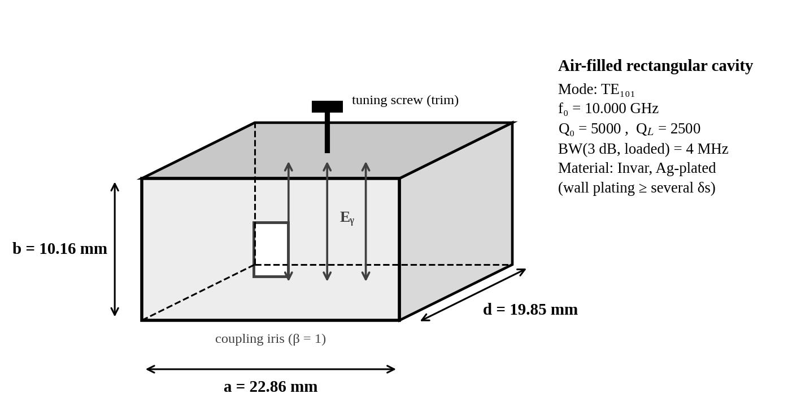
Figure 3. Dimensioned sketch of the TE101 rectangular cavity resonator (a × b × d = 22.86 × 10.16 × 19.85 mm)
Parameter | Brass cavity | Invar cavity (silver-plated)
Dimensions a × b × d | 22.86 × 10.16 × 19.85 mm | 22.86 × 10.16 × 19.85 mm
Unloaded Q₀ / loaded Q_L (β = 1) | 5000 / 2500 (assumed) | 5000 / 2500 (assumed; needs plating)
3 dB bandwidth (loaded) | 4.0 MHz | 4.0 MHz
Thermal coefficient α | 19 ppm/°C | 1.3 ppm/°C
Drift per °C | −190 kHz/°C | −13 kHz/°C
Drift for +20 °C | −3.80 MHz (95 % of the 4 MHz bandwidth) | −0.26 MHz (6.5 % of the bandwidth)
Other material considerations | Easy to machine, low cost, high conductivity | About 14.6× less drift. Bare Invar has poor conductivity, so silver or gold plating (several skin depths) is needed to keep Q. Higher cost and harder to machine.

Engineering significance. With brass, a 20 °C rise moves the resonance by almost the entire 4 MHz loaded bandwidth, so a brass cavity would lose lock under hot-afternoon conditions. Invar keeps the shift to a small fraction of the bandwidth, so the AFC only has to correct a small residual error. Note also that the 40 MHz LO shift in the field data would need a temperature rise of about 40 MHz/(190 kHz/°C) ≈ 210 °C in brass, so dimensional expansion of a cavity alone does not explain the field observation (see Section 5).
Design Decision 2
I would choose a rectangular TE101 air-filled cavity made from silver-plated Invar because its thermal drift is 13 kHz/°C (0.26 MHz for a 20 °C rise) against 190 kHz/°C (3.8 MHz) for brass, which is only 6.5 % rather than 95 % of the 4 MHz loaded bandwidth. The silver plating preserves Q₀ ≈ 5000, and the loaded bandwidth of 4 MHz is adequate for AFC capture.

4.2 Receiver protection, mixer and noise performance (Stage 4 – 20 marks)

PIN-diode operation and reactance
A PIN diode acts as a current-controlled resistor. In forward bias the injected carriers in the intrinsic region give a low resistance (Rs = 1.5 Ω). In reverse bias the intrinsic region is depleted and the diode is a small capacitor Cj = 0.12 pF in parallel with a very high resistance.
X_C = 1/(2πf·Cj) = 1/(2π × 10 × 10⁹ × 0.12 × 10⁻¹²) = 1/(7.54 × 10⁻³) = 132.6 Ω (order of 10² Ω)
Series switch, forward (pass): IL = 20 log₁₀(1 + Rs/2Z₀) = 20 log₁₀(1 + 1.5/100) = 0.13 dB
Series switch, reverse (isolate): Iso = 20 log₁₀|1 − jX_C/2Z₀| = 20 log₁₀|1 − j1.326| = 4.4 dB
Shunt switch, reverse (pass): IL = 20 log₁₀|1 + jωCj·Z₀/2| = 0.15 dB
Shunt switch, forward (isolate): Iso = 20 log₁₀(1 + Z₀/2Rs) = 20 log₁₀(1 + 16.7) = 24.9 dB
Implication. The 132.6 Ω reactance is of the same order as Z₀. A single series diode would give only 4.4 dB of isolation at 10 GHz, so it cannot protect a mixer. A shunt diode that is forward-biased in the protect state gives about 25 dB per diode, and the 32 dB at commissioning needs a multi-diode or tuned design. Isolation depends on Rs, so any rise in effective Rs (poor forward bias, ageing or a damaged contact) degrades protection directly. The insertion loss of the pass state is small (0.13–0.15 dB) for the intrinsic diode. In the noise analysis a practical value of 0.5 dB is assumed for the complete switch, including mount and transitions.

Mixer leakage risk
Available data are not enough for a unique result. The missing parameters are the circulator's transmit-to-receive isolation (only its 0.5 dB insertion loss is given), the limiter clamp level, the LNA survival level, the reflected-Tx path via the antenna, and the duty cycle. A defensible worst-case method is to take the full 2 W transmitter power, assume 0 dB circulator isolation (the unknown), and subtract only the known PIN isolation:
P_mixer = P_Tx − I_circ − I_PIN − A_lim + G_LNA with P_Tx = 33.01 dBm, I_circ = 0 dB (worst case), A_lim = 0 dB (no limiter yet)
Mixer-only receiver, commissioning (I_PIN = 32 dB): 33.01 − 32 = +1.0 dBm = 1.26 mW → 9.0 dB below the 10 mW limit
Mixer-only receiver, after six months (I_PIN = 21 dB): 33.01 − 21 = +12.0 dBm = 15.9 mW → exceeds 10 mW by 2.0 dB
With LNA (G = 18 dB), no limiter, commissioning: 1.0 + 18 = 19.0 dBm = 79.6 mW → 9.0 dB over the limit
With LNA (G = 18 dB), no limiter, after six months: 12.0 + 18 = 30.0 dBm = 1.0 W → 20 dB over the limit
Required extra isolation (circulator plus limiter) to bring the mixer input to ≤ 0 dBm (10 dB margin) is 12 dB without an LNA and 30 dB with an LNA when the PIN isolation is degraded to 21 dB. Interpretation: the commissioned receiver was safe even in this worst case, but at 21 dB isolation it is not. Adding an LNA without an additional limiter would make mixer burnout almost certain, and the LNA input itself would see +1 to +12 dBm.

Image frequency
Low-side LO: f_LO = f_RF − f_IF = 10.000 − 0.100 = 9.900 GHz → f_image = f_LO − f_IF = 9.800 GHz (= f_RF − 2f_IF)
High-side LO: f_LO = f_RF + f_IF = 10.000 + 0.100 = 10.100 GHz → f_image = f_LO + f_IF = 10.200 GHz (= f_RF + 2f_IF)
The image lies 200 MHz (2 %) from the signal, so a selective RF image filter (or an image-reject mixer) is required before the mixer. The 9.90 GHz LO in the field data corresponds to the low-side option.

Cascade noise figure (Friis) and minimum detectable signal
Assumptions: isolator 0.5 dB loss (given) and PIN switch 0.5 dB loss (assumed), so each has F = 1.122 and G = 0.891. Mixer NF = 7 dB (F = 5.012) with G = −7 dB (0.1995). IF amp F = 1.585, G = 35 dB. LNA F = 1.585, G = 18 dB (63.1). T = 290 K.
F_total = F₁ + (F₂ − 1)/G₁ + (F₃ − 1)/(G₁G₂) + (F₄ − 1)/(G₁G₂G₃) + …
(i) Isolator + PIN + mixer + IF amp:
F = 1.1220 + 0.1220/0.8913 + 4.0119/0.7943 + 0.5849/0.1585 = 1.1220 + 0.1369 + 5.0508 + 3.6910 = 10.00 → NF = 10.00 dB
(ii) Isolator + PIN + LNA + mixer + IF amp:
F = 1.1220 + 0.1369 + 0.5849/0.7943 + 4.0119/50.12 + 0.5849/9.999 = 1.1220 + 0.1369 + 0.7364 + 0.0800 + 0.0585 = 2.134 → NF = 3.29 dB
(ii-L) same as (ii) with an input limiter (assumed 0.5 dB loss) before the LNA: NF = 3.79 dB
Thermal noise (input-referred): P_n = kT₀B = 1.381 × 10⁻²³ × 290 × 2 × 10⁶ = 8.01 × 10⁻¹⁵ W = −110.96 dBm
MDS = P_n + NF + SNR_req = −110.96 + NF + 10 dB
(i) MDS = −110.96 + 10.00 + 10 = −90.96 dBm
(ii) MDS = −110.96 + 3.29 + 10 = −97.67 dBm (ii-L) MDS = −97.17 dBm
Receiver configuration | Noise figure | MDS (2 MHz, 10 dB SNR) | Improvement vs (i)
(i) Isolator + PIN + mixer + IF amp | 10.00 dB | −90.96 dBm | —
(ii) Isolator + PIN + LNA + mixer + IF amp | 3.29 dB | −97.67 dBm | 6.71 dB
(ii-L) as (ii) plus 0.5 dB limiter (assumed) | 3.79 dB | −97.17 dBm | 6.21 dB

Engineering significance. Without an LNA, the 7 dB mixer loss and then the IF amplifier noise dominate: of the total F = 10.0, 5.05 comes from the mixer and 3.69 from the IF amplifier. The LNA's 18 dB gain reduces those terms to 0.08 and 0.06, so the front-end losses and the LNA itself set the NF. The protection devices must therefore be low-loss, since every 0.1 dB ahead of the LNA costs 0.1 dB of sensitivity.

Upgraded receiver and protection of the LNA
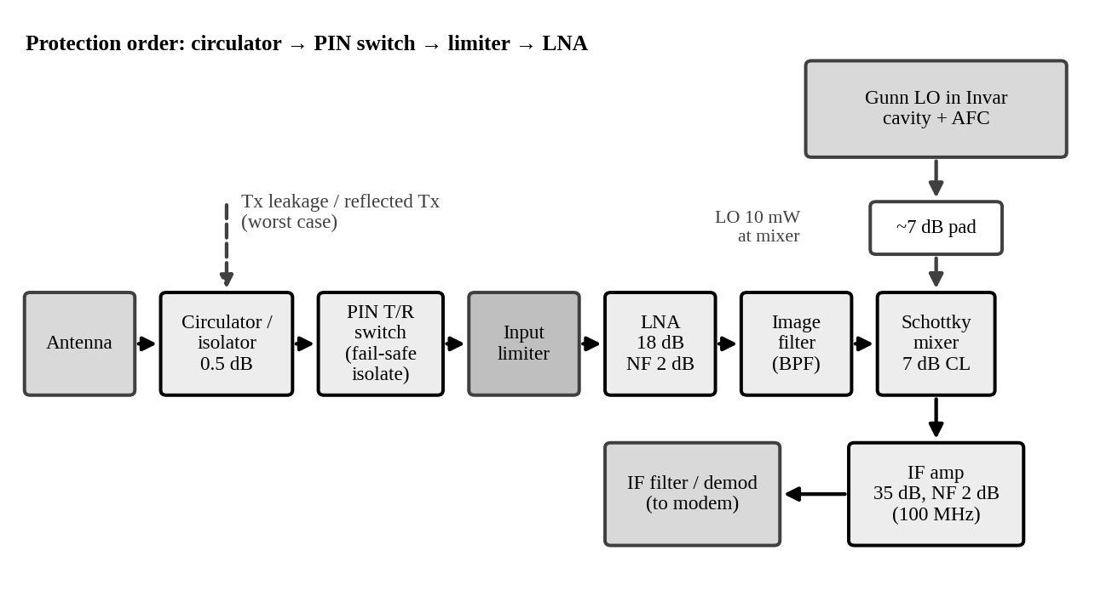
Figure 4. Upgraded receiver block diagram with limiter, PIN switch and LNA
Order and justification: antenna → circulator → PIN T/R switch → input limiter → LNA → image filter → mixer → IF amplifier.
- The circulator gives the first, passive Tx–Rx isolation and also reduces the reflected Tx seen by the receiver.
- The controlled PIN switch handles the main high-power event: it is switched to its isolating (shunt, forward-biased) state during transmit.
- The passive limiter follows it as a fast back-up that clamps residual leakage, switching spikes and any PIN failure. It needs no bias and operates in nanoseconds, which is why it sits closest to the LNA.
- The LNA must come before the mixer and as early as possible for noise, but only after all protection. The image filter follows the LNA to remove image noise, and the mixer and IF amplifier then see much less noise penalty.
Preventing LNA damage from transmit leakage: (1) Sequence the PIN switch so that isolation is applied before RF is turned on and released only after it is off. (2) Make the PIN bias fail-safe, so that loss of bias or a controller fault leaves the receiver in the isolating state. (3) Provide Tx–Rx isolation such that peak leakage at the LNA input is at least 6–10 dB below its rated survival input (a data-sheet item that is missing from the case). (4) Monitor leakage (the coupler or a detector) and trip the transmitter on a fault. (5) Check switch isolation periodically; the field data show it can degrade.
Design Decision 4
I recommend receiver configuration (ii) with an LNA, protected by circulator + PIN switch + limiter, because it improves NF from 10.0 dB to about 3.3–3.8 dB and MDS from −91.0 dBm to about −97.2 to −97.7 dBm (6.2–6.7 dB better). It is conditional on restoring the PIN isolation to ≥ 32 dB and on the limiter, because the LNA gain increases the leakage reaching the mixer by 18 dB.

5. DIAGNOSIS (Stage 5 – 20 marks)

5.1 Change in forward power
ΔP = 10 log₁₀(P₂/P₁) = 10 log₁₀(13 mW / 20 mW) = 10 log₁₀(0.65) = −1.87 dB
Implied transmitter output (coupling constant at 20 dB): 13 mW × 100 = 1.30 W instead of 2.0 W (−35 %)
Why this is an indicator, not proof. The calculation assumes that the coupling factor, the detector or power-meter calibration, connector repeatability and temperature behaviour are unchanged. In reality the coupling varies with frequency and temperature, the forward port also responds to re-reflected power (source and load mismatch create a standing wave), and the reading depends on the test setup. A 1.87 dB fall could therefore be partly a measurement or coupler change rather than a real fall of transmitter output. An independent power-meter measurement is needed to confirm it.

5.2 Reverse-to-forward ratio and the limit set by directivity
Commissioning: 0.10 mW / 20 mW = 0.00500 = −23.01 dB → |Γ|_app = √0.005 = 0.0707 → VSWR_app = 1.15
After six months: 0.55 mW / 13 mW = 0.0423 = −13.74 dB → |Γ|_app = √0.0423 = 0.2057 → VSWR_app = 1.52
Change: 0.0423/0.005 = 8.46× (+9.27 dB)
Directivity: D = 25 dB → leakage amplitude = 10^(−25/20) = 0.0562
Commissioning true |Γ| between 0.0707 − 0.0562 = 0.0145 and 0.0707 + 0.0562 = 0.1269 → VSWR 1.03 to 1.29
After six months true |Γ| between 0.2057 − 0.0562 = 0.1495 and 0.2057 + 0.0562 = 0.2619 → VSWR 1.35 to 1.71
The reverse port reads Γ_true plus the leakage wave (whose phase is unknown), so the inferred VSWR is a range and not a single number. At commissioning the range (1.03–1.29) includes the stated VSWR of 1.25, as expected. After six months even the most favourable case (VSWR 1.35) is worse than the stated 1.25, so a degraded antenna match is a directly supported conclusion. The exact value is not. If the 3 dB pad lies between the coupler and the antenna, the antenna-plane |Γ| is 1.995× larger (≈ 0.41, VSWR ≈ 2.4), so the figures above are conservative. The mismatch loss at the coupler plane, −10 log₁₀(1 − 0.2057²) = 0.19 dB, is small, so the mismatch alone cannot explain the 1.87 dB forward-power fall. Its significance is physical damage and the stress put on the transmitter.

5.3 LO frequency shift
Δf_LO = 9.86 − 9.90 = −0.040 GHz = −40 MHz
Δf/f = −40 MHz / 9900 MHz = −0.404 % (−4040 ppm)
IF (low-side LO) = f_RF − f_LO = 10.000 − 9.860 = 140 MHz instead of 100 MHz; image moves 9.80 → 9.72 GHz
The IF is displaced by 40 MHz (40 % of the IF). Against a channel bandwidth of the order of the 2 MHz used in Stage 4, this puts the signal outside the IF filter and the demodulator, which matches the symptom of intermittent throughput loss on hot afternoons. The temperature rise during hot operation is not supplied, so a drift coefficient (ppm/°C) cannot be calculated. The shift also cannot be explained by dimensional expansion of a brass cavity alone (≈ 210 °C would be needed), so oscillator-device thermal effects (junction temperature, bias or varactor drift) or the lack of AFC are the more likely causes.

5.4 Ranked root causes
Ranking is by evidence-weighted severity (consequence for service or equipment multiplied by the strength of the evidence):
Rank | Fault / symptom | Evidence | Probable mechanism | System impact | Severity | Confirmation test
1 | PIN-switch deterioration | Isolation 32 → 21 dB (−11 dB). Worst-case mixer leakage +12.0 dBm (15.9 mW) > 10 mW limit. Single-shunt model: Rs ≈ 0.64 → 2.4 Ω (×3.8, first-order) | Lower forward bias or driver drift, ageing diode (higher Rs), poor contact or damaged junction | Tx leakage reaches the mixer and LNA; risk of irreversible damage; reduced isolation margin | Critical | Bench VNA S₂₁ in isolate state; bias current and V–I check; driver timing test
2 | LO thermal drift | LO 9.90 → 9.86 GHz when hot (−40 MHz, −0.404 %); stable at room temperature | Uncompensated Gunn oscillator (junction or bias temperature, varactor), no AFC, expansion of the mount | IF moves 100 → 140 MHz, outside the IF filter; throughput loss on hot afternoons | High | Thermal-chamber sweep with counter; IF spectrum; bias stability
3 | Antenna mismatch | Reverse/forward 0.005 → 0.0423 (+9.3 dB); VSWR_app 1.15 → 1.52 (range 1.35–1.71) | Water ingress, corroded or loose connector, damaged feed or radome, misalignment | More reflected power to the Tx, load pulling, about 0.19 dB mismatch loss (≈ 0.8 dB if pad in line) | High–Med | Calibrated VNA or DTF at the feed with a ≥ 40 dB directivity coupler; visual check
4 | Transmitter output degradation | Forward coupled 20 → 13 mW (−1.87 dB; 2.0 → 1.3 W) | PA ageing or thermal derating, bias drift, higher output-isolator loss, or a coupler/detector change | 1.87 dB loss of link margin and received level | Medium (indicator only) | Power meter on the through-port into a dummy load; measure PA bias; check coupling factor
5 | Mixer damage | Only a report of intermittent degradation; no electrical data | Overdrive by Tx leakage (hypothesis, linked to rank 1) or LO overdrive; aged Schottky junction | Higher conversion loss and noise figure; intermittent behaviour | Medium (hypothesis) | Mixer diode DC I–V; conversion loss at 10 mW LO; Y-factor NF; swap with a spare

Directly supported by data: (a) forward coupled reading fell by 1.87 dB; (b) reverse/forward ratio rose by 9.3 dB and the true VSWR is above 1.35 even allowing for directivity; (c) PIN isolation fell by 11 dB, and with I_circ = 0 the worst-case leakage exceeds the mixer limit; (d) the LO moves by 40 MHz when hot and displaces the IF by the same amount.
Hypotheses needing further tests: (a) that the transmitter itself has degraded (rather than the coupler or measurement); (b) the physical cause of the antenna mismatch; (c) the failure mechanism of the PIN switch; (d) the cause of the LO drift (Gunn device, bias or mount); (e) that the mixer is damaged, and that it was caused by PIN leakage.

5.5 Short diagnostic test plan
- Safety first: operate the receiver with the transmitter at reduced power (or add a temporary attenuator or limiter) until PIN isolation is verified.
- Transmit power: a calibrated power meter on the through-port into a dummy load; compare with the coupled-port reading to separate real PA degradation from coupler or detector error.
- Antenna match: a VNA return-loss sweep or distance-to-fault at the feed using a ≥ 40 dB directivity coupler (or full one-port calibration); inspect the connectors, feed and radome for moisture.
- PIN switch: a bench test of isolation and insertion loss versus bias current; forward V–I (Rs); check driver timing and fail-safe state.
- LO: a thermal-chamber sweep (for example 0–60 °C) of LO frequency and power; log the bias voltage and current; observe the IF spectrum for the 40 MHz offset.
- Mixer: DC I–V check, conversion loss at 10 mW LO drive, and Y-factor noise figure; compare with a known-good spare.

6. ENGINEERING RECOMMENDATION (Final Decision – 10 marks)

6.1 First corrective action
First action
Restore receiver protection: bench-test and replace (or re-bias) the PIN switch, and fit an input limiter ahead of the receiver. This must be done before any other upgrade, and above all before adding an LNA.

Justification from Stages 1–5. (i) PIN isolation fell by 11 dB (Stage 5), and the worst-case mixer leakage is now +12.0 dBm (15.9 mW), above the 10 mW safe limit (Stage 4). (ii) It is the only fault that can cause irreversible damage, and it is a plausible cause of the reported mixer degradation. (iii) Every later improvement makes it worse: an 18 dB LNA would raise the leakage to +30 dBm. (iv) The other faults (LO drift, mismatch) degrade service but do not destroy equipment. (v) It is also a low-cost and fast action.

6.2 Prioritised plan
Priority | Action | Justification (evidence)
1 | Replace or re-bias the PIN switch and add an input limiter; verify isolation ≥ 32 dB | Isolation −11 dB; worst-case leakage 12.0 dBm > 10 dBm limit
2 | Verify Tx power with a power meter. Replace the monitoring coupler with a ≥ 40 dB directivity unit and move the 3 dB pad ahead of it. Inspect and repair the antenna feed to restore VSWR ≤ 1.25 | Forward −1.87 dB; reverse/forward +9.3 dB; the present 25 dB directivity cannot resolve VSWR 1.25
3 | Stabilise the LO: Gunn in a silver-plated Invar TE101 cavity with varactor AFC | −40 MHz hot drift moves the IF to 140 MHz; Invar gives −13 kHz/°C (−0.26 MHz per 20 °C)
4 | Add the LNA behind the PIN switch and limiter (configuration ii) | NF 10.0 → 3.3–3.8 dB; MDS improves by 6.2–6.7 dB
5 | Adopt the Wilkinson divider for a two-branch feed only if the two-antenna design is approved | Matched input and isolated branches, but each branch gets −3 dB; no benefit to a single-antenna link

6.3 Expected improvement (where data allow calculation)
Quantity | Present / field value | Expected after upgrade | Improvement
Worst-case mixer leakage (I_circ = 0) | +12.0 dBm (15.9 mW) | ≤ +1.0 dBm (1.26 mW) at 32 dB isolation; lower with a limiter | ≥ 11 dB
Receiver noise figure | 10.00 dB | 3.29 dB (3.79 dB with limiter) | 6.2–6.7 dB
Minimum detectable signal (2 MHz, 10 dB SNR) | −90.96 dBm | −97.67 dBm (−97.17 dBm) | 6.2–6.7 dB
LO drift for +20 °C | −40 MHz (field, ΔT unknown) | ≤ 0.26 MHz cavity-limited (Invar); less with AFC | about 150× (cavity term only)
Forward coupled reading (if Tx fault is confirmed) | 13 mW | 20 mW | +1.87 dB
Mismatch loss at the coupler plane | 0.19 dB (VSWR_app 1.52) | 0.02 dB (VSWR 1.15) | 0.17 dB

If all three link-level items are confirmed and repaired, the upper bound on link-margin recovery is about 6.7 + 1.87 + 0.17 ≈ 8.7 dB (receiver sensitivity, transmit power and match). This is an upper bound because the Tx fault is only an indicator at present, and a complete link budget (path loss, antenna gains, fade margin) is not given.

6.4 Comparison of options
Option | Scope | Cost | Complexity | Reliability | Risk
A – Restore and protect | PIN switch + limiter; Tx power check; high-directivity coupler; antenna repair | Low–Medium | Low | Restores commissioning performance; NF stays 10 dB | Low; LO drift persists, so hot-afternoon outages continue
B – A plus LO stabilisation | A + Invar cavity Gunn with AFC | Medium | Medium | High; removes the thermal outage cause | Low–Medium; needs thermal-chamber validation and tuning effort
C – B plus LNA and Wilkinson feed | B + protected LNA (config ii) + two-branch Wilkinson feed | High | High | Highest performance (NF about 3.3–3.8 dB) | Medium; LNA burnout if protection fails; −3 dB per branch; more parts to maintain

Recommendation: implement Option B now (it removes both the equipment-damage risk and the thermal throughput loss), and add the LNA from Option C as a second phase when the link-margin requirement justifies it. The Wilkinson feed is adopted only after a two-branch antenna design is approved.

6.5 Confirming successful repair
Measurement | Method | Proposed acceptance criterion
Forward / reverse power | Power meter at the through-port; coupler readings | Forward coupled ≈ 20 mW at 2 W (within ±0.3 dB of commissioning); reverse/forward ≤ −23 dB
Return loss / VSWR | Calibrated VNA sweep at the antenna feed | RL ≥ 19 dB (VSWR ≤ 1.25) across the band
PIN-switch isolation | VNA S₂₁ in isolate state, in-circuit and on the bench | ≥ 32 dB, with peak leakage at the mixer ≤ 0 dBm
LO frequency versus temperature | Thermal chamber with counter (0–60 °C) | ≤ 0.3 MHz per 20 °C free-running; AFC locked; IF = 100 MHz ± 1 MHz
Mixer input level | Power meter or detector at the mixer RF port during transmit | ≤ 0 dBm (10 dB below the 10 mW limit)
Receiver noise figure | Y-factor with a calibrated noise source | ≤ 3.5 dB (with LNA, without limiter); ≈ 3.8 dB with limiter

7. CONCLUSION
The coupler's 25 dB directivity is too low to monitor a VSWR 1.25 antenna reliably. The TE101 cavity (22.86 × 10.16 × 19.85 mm) in silver-plated Invar gives a drift of only 13 kHz/°C and a 4 MHz loaded bandwidth at 10 GHz. A cavity-stabilised Gunn oscillator is the best LO choice. Receiver protection is the most urgent problem, since the degraded PIN switch (21 dB) can let up to 15.9 mW reach the 10 mW-rated mixer in the worst case. The LNA configuration cuts NF from 10.0 dB to about 3.3 dB, but only behind a limiter and a healthy PIN switch. The ranked diagnosis (PIN switch, LO drift, antenna mismatch, transmitter output, mixer damage) leads to a staged plan: protect first, then stabilise the LO, then add the LNA.

REFERENCES
[1] D. M. Pozar, Microwave Engineering, 4th ed., Wiley, 2012 (directional couplers, power dividers, resonators, noise figure and Friis formula).
[2] S. Y. Liao, Microwave Devices and Circuits, 3rd ed., Prentice Hall, 1990 (Gunn, IMPATT, klystron, TWT, magnetron, PIN and Schottky diodes).
[3] R. E. Collin, Foundations for Microwave Engineering, 2nd ed., Wiley-IEEE Press, 2001.
[4] A. Das and S. K. Das, Microwave Engineering, McGraw-Hill Education (India).
[5] J. B. Gunn, “Microwave oscillations of current in III-V semiconductors,” Solid State Communications, vol. 1, no. 4, pp. 88–91, 1963.
[6] W. T. Read, “A proposed high-frequency negative-resistance diode,” Bell System Technical Journal, vol. 37, no. 2, pp. 401–446, 1958.
[7] D. B. Leeson, “A simple model of feedback oscillator noise spectrum,” Proc. IEEE, vol. 54, no. 2, pp. 329–330, 1966.
[8] E. J. Wilkinson, “An N-way hybrid power divider,” IRE Trans. Microwave Theory Tech., vol. 8, no. 1, pp. 116–118, 1960.
[9] H. T. Friis, “Noise figures of radio receivers,” Proc. IRE, vol. 32, no. 7, pp. 419–422, 1944.
Note: the typical device ranges in Section 3 are textbook-level values and should be confirmed against manufacturer data sheets. No data sheets were supplied with the case.

